A Mobile Application for Facility Management

Team
Cloud
Members
Toqa Eldaoushy | 13007068 (Team Lead)
Seif Fattah | 13003679
Malak Abdelnabi | 13002687
Sarah Ahmed | 13007752
Sara Samy | 13006900
Malak Ehab | 13006450

Tutorial Details

T:1 | TA: Moamen Alaa

1. Introduction
A mobile application will be created to allow members of the GIU community to report issues related to infrastructure, maintenance, sustainability, and cleanliness that need the attention of the Facility Management team. Examples of such issues include broken doors, flickering lights, open windows while the air conditioning is running, and overflowing trash bins.

The system will enable the Facility Management team to receive these reports, assign the appropriate personnel, and monitor and update the status of each issue. Status updates will be visible to the users who submitted the reports.

This application aims to support efficient campus maintenance and help preserve campus assets. It is expected to improve response times to reported problems, resulting in a cleaner, safer, and more comfortable environment for community members.

The solution will be developed as a mobile application using React Native with Expo, supported by a backend built with Node.js and RESTful APIs.

This Software Requirements Specification (SRS) document provides a comprehensive overview of the GIU Facility Management Mobile Application. It is intended for developers, project managers, testers, and stakeholders to ensure a common understanding of the proposed system.

1.1 Product Vision & Scope
The vision of the GIU Facility Management Mobile Application is to create a seamless,
efficient, and collaborative platform that empowers every member of the GIU community
to participate in maintaining campus facilities, while enabling the Facility Management
team to deliver faster, more effective service.

The scope includes:
• A mobile application for Android and iOS built with React Native and Expo
• User authentication with four roles: Community Member, Facility Manager, Worker, and Admin
• Ticket submission with photo attachment, location selection, category choice, and description
• Real-time notifications for submission confirmation and status changes
• Dashboard for managers to view, filter, and assign tickets
• Worker view showing assigned tasks with ability to update progress and status
• Admin functions for user management and system configuration
• Secure cloud storage for images
• PostgreSQL database backend with RESTful APIs

1.2 Definitions and Acronyms
SRS: Software Requirements Specification
Ticket: A digital record representing a maintenance issue
RBAC: Role-Based Access Control
FR Functional Requirement - what the system does
NFR Non-Functional Requirement - how well the system does it
Facility Manager Staff member who assigns and monitors tickets

2. User stories:

2.1 Community Member
US-CM-01:
As a Community Member, I should be able to create an account so that I can log in to the application.

US-CM-02:
As a Community Member, I should be able to log in using my email and password so that I can access the application

US-CM-03:
As a Community Member, I should be able to submit an issue with its details (location, photo, and category) so that the problem can be reported accurately.

US-CM-04:
As a Community Member, I should be able to add a description to the issue so that the worker understands the problem clearly.
US-CM-05:
As a Community Member, I should be able to view my submitted issues so that I can track their status.

US-CM-06:
As a Community Member, I should be able to log out so that my data remains secure on shared devices.

US-CM-07
As a Community Member, I should be able to view the status of my issue (Pending, In Progress, Resolved) so that I know the progress of my request.

2.2 Facility Manager
US-FM-01:
As a Facility Manager, I should be able to create an account so that I can log in to the application.

US-FM-02:
As a Facility Manager, I should be able to log in using my email and password so that I can access the application.

US-FM-03:
As a Facility Manager, I should be able to log out so that my data remains secure on shared devices.

US-FM-04:
As a Facility Manager, I should be able to view all submitted issues so that I can assign them to workers.

US-FM-05:
As a Facility Manager, I should be able to update an issue’s status so that the system reflects the current state of the issue.

US-FM-06
As a Facility Manager, I should be able to assign an issue to a worker so that the worker can start fixing it.

US-FM-07
As a Facility Manager, I should be able to close an issue after it is resolved so that the system reflects that the issue is completed.

2.3 Worker
US-W-01:
As a Worker, I should be able to create an account so that I can log in to the application.

US-W-02:
As a Worker, I should be able to log in using my email and password so that I can access the application.

US-W-03:
As a Worker, I should be able to log out so that my data remains secure on shared devices.

US-W-04:
As a Worker, I should be able to view my assigned issues so that I can start working on them.

US-W-05:
As a Worker, I should be able to comment on an issue to indicate that the work is completed so that the facility manager can update its status.

US-W-06
As a Worker, I should be able to mark an issue as “In Progress” so that the facility manager and community member know that it is being worked on.

US-W-07
As a Worker, I should be able to upload a photo after fixing the issue so that the facility manager can verify the work.

2.4 System Admin (optional for Now):
US-SA-01:
As a System Admin, I should be able to log in so that I can access the application.

US-SA-02:
As a System Admin, I should be able to log out so that my data remains secure on shared devices.

US-SA-03:
As a System Admin, I should be able to activate or deactivate any account so that I can ensure all users follow the system rules.

US-SA-04
As a System Admin, I should be able to view all registered users so that I can manage the system users.
3. Functional Requirements:

3.1 Community Member Functional Requirements

FR-CM-01 (Register):The system shall allow a Community Member to Register by providing required information (e.g., name, email, and password).
FR-CM-02 (Login): The system shall allow a Community Member to log in using a valid email and password.
FR-CM-03: Issue Submission: The system shall allow a Community Member to submit an issue including the following details:
- Location
- Photo
- Category
- Description
FR-CM-04 (Add Description & Category): The system shall allow users to choose a ticket category (e.g., electrical, plumbing, cleanliness, sustainability) and enter a short textual description
FR-CM-05 (View Submitted Issue): The system shall allow users to view a list of all issues.
FR-CM-06 (View Issue Status): The system shall display the current status of an issue to the Community Member.
Possible statuses include:
- Pending
- In Progress
- Resolved
FR-CM-07: Logout
The system shall allow a Community Member to log out of the application.
Extra FR-CM:
FR-CM-08 (View Ticket Details): The system shall allow users to open a ticket and view its full details (photo(s), description, category, location, status history, timestamps).
FR-CM-09 (Search/Filter Tickets): The system shall allow users to search and filter tickets by category, status, and location.

3.2 Facility Manager Functional Requirements
FR-FM-01 (Account Creation):The system shall allow a Facility Manager to create an account.
FR-FM-02 (User Authentication): The system shall allow a Facility Manager to log in using a valid email and password.
FR-FM-03 (Manager Dashboard): The system shall provide managers with a dashboard to view all tickets and their statuses.
FR-FM-04 (Assign Worker): The system shall allow managers to assign a ticket to a worker.
FR-FM-05 (Update Issue Status): The system shall allow managers to update ticket status (New → Assigned → In Progress → Resolved).
FR-FM-06 (Close Issue): The system shall allow a Facility Manager to close an issue once it has been resolved.
FR-FM-07 (Logout): The system shall allow a Facility Manager to log out of the application.
Extra FR-CM:
FR-FM-03 (View Ticket Details): The system shall allow managers to view ticket details including photo(s), location, category, description, reporter, and timestamps.
FR-FM-03 (Set Priority): The system shall allow managers to set a priority level (e.g., Low/Medium/High/Urgent).
FR-FM-03 (Add Internal Notes): The system shall allow managers to add internal notes not visible to community members.

3.3 Worker Functional Requirements
FR-W-01 (Account Creation): The system shall allow a Worker to create an account.
FR-W-02 (User Authentication): The system shall allow a Worker to log in using a valid email and password.
FR-W-03 (View Assigned Tasks): The system shall allow workers to view a list of tickets assigned to them (“My Tasks”).
FR-W-04 (Change Status): The system shall allow workers to update the issue in progress.
FR-W-05 (Comment on Issue): The system shall allow a Worker to add comments to an issue.
FR-W-06 (Upload Completion Photo): The system shall allow a Worker to upload a photo after completing the work on an issue.
FR-W-07 (Logout): The system shall allow a Worker to log out of the application.
Extra FR-CM:
FR-W-08 (Task Details): The system shall allow workers to view ticket details including location, photo(s), description, and priority.

3.4 System Admin Functional Requirements
FR-SA-01 (Admin Authentication): The system shall allow a System Admin to log in.
FR-SA-02 (Manage Users): The system shall allow admins to create, activate/deactivate, and manage user accounts and to assign roles (Community Member / Manager / Worker / Admin) and enforce RBAC.
FR-SA-03 (View Registered Users): The system shall allow a System Admin to view all registered users in the system.
FR-SA-04 (Logout): The system shall allow a System Admin to log out.

3.5 Product Backlog
Backlog ID | User Story ID | Priority
Core System Features
PB-01 | US-CM-01 | High
PB-02 | US-CM-02 | High
PB-03 | US-CM-03 | High
PB-04 | US-CM-04 | High
PB-05 | US-CM-05 | High
PB-06 | US-CM-07 | High
PB-07 | US-FM-01 | High
PB-08 | US-FM-02 | High
PB-09 | US-W-01 | High
PB-10 | US-W-02 | High
Issue Management Features
PB-11 | US-FM-04 | High
PB-12 | US-FM-06 | High
PB-13 | US-W-04 | High
PB-14 | US-W-06 | High
PB-15 | US-W-05 | Medium
PB-16 | US-W-07 | Medium
PB-17 | US-FM-05 | High
PB-18 | US-FM-07 | High
Authentication & Security
PB-19 | US-CM-06 | Medium
PB-20 | US-FM-03 | Medium
PB-21 | US-W-03 | Medium
System Administration (Optional)
PB-22 | US-SA-01 | Low
PB-23 | US-SA-02 | Low
PB-24 | US-SA-03 | Low
PB-25 | US-SA-04 | Low

3.6 UML Use-case Diagram
Include a UML use-case diagram for your system here. It should include the system, all actors, and their relationships.
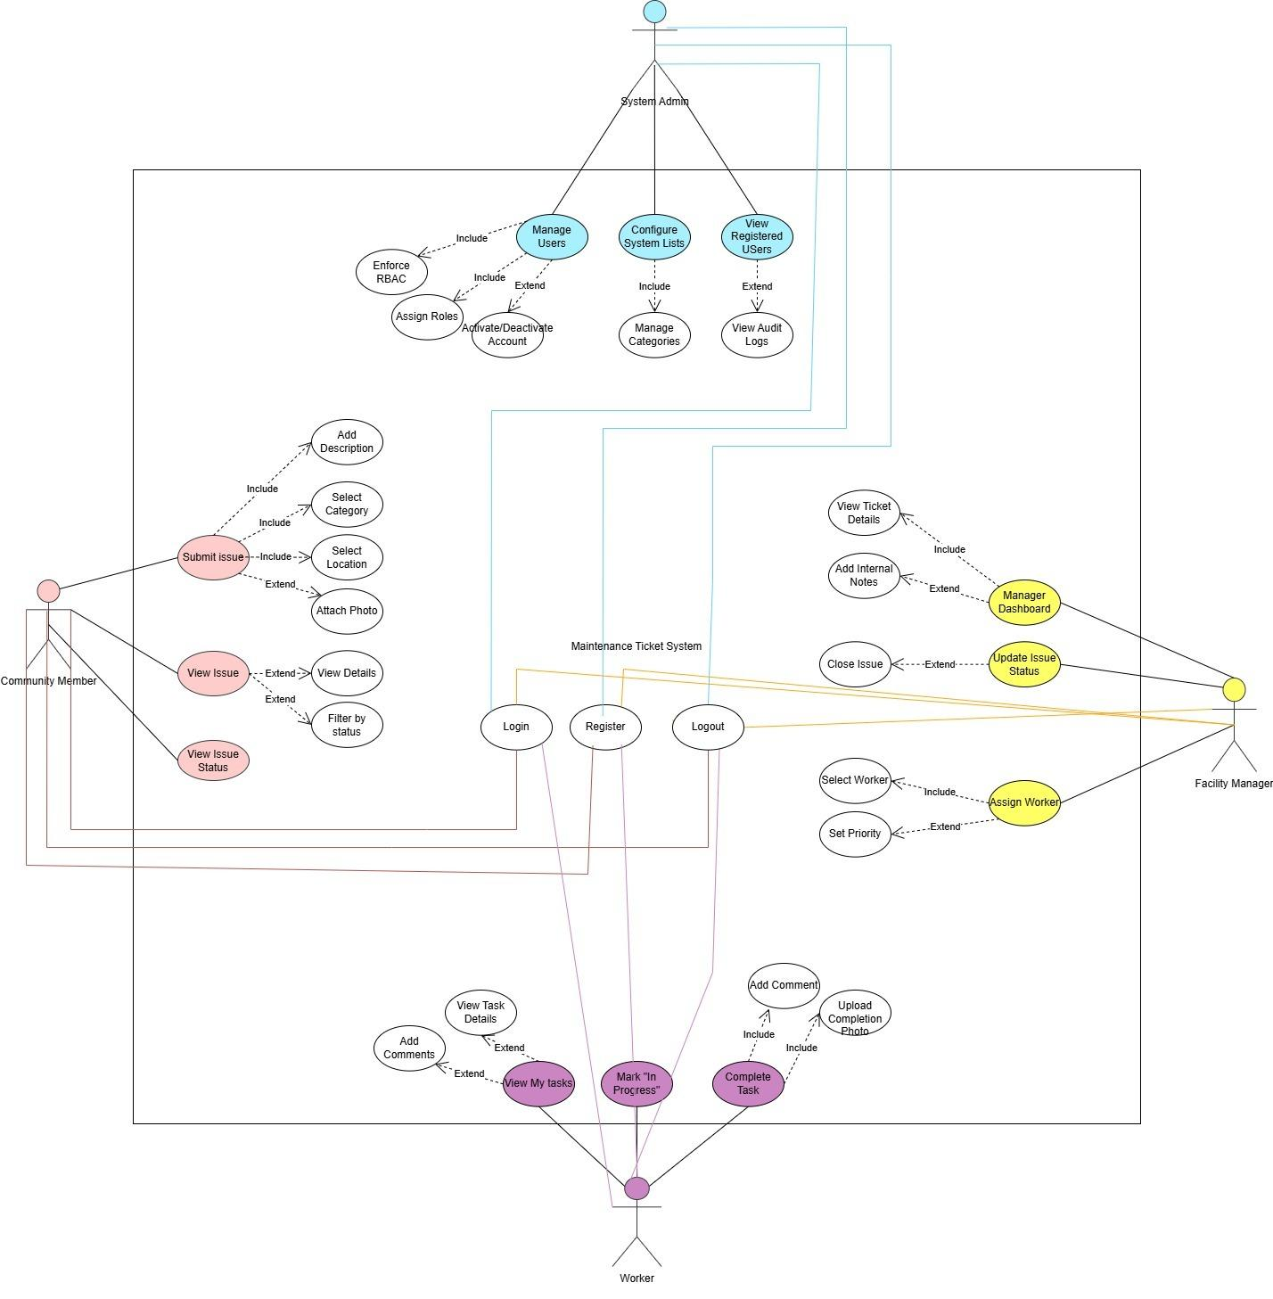

4. Non-Functional Requirements

4.1 Performance Requirements

NFR-01 – Response Time

The system shall load any mobile application screen within 5 seconds under normal internet conditions.

NFR-02 – Ticket Submission Time

The system shall complete ticket submission, including image upload, within 10 seconds on a stable internet connection.

4.2 Availability and Reliability Requirements

NFR-03 – System Availability

The system shall be operational during official university working hours.

NFR-04 – Data Persistence

All submitted tickets and status updates shall be permanently stored in the PostgreSQL database to prevent data loss.

4.3 Security Requirements

NFR-05 – Authentication

Users shall be required to log in before accessing any system functionality.

NFR-06 – Authorization (Role-Based Access Control)

The system shall enforce role-based access control to restrict actions according to user roles (Community Member, Worker, Manager, Admin).

NFR-07 – Secure Communication

All communication between the mobile application and backend server shall be secured using HTTPS.

NFR-08 – Password Protection

User passwords shall be stored using secure hashing algorithms (e.g., bcrypt).

3.4 Usability Requirements

NFR-09 – Ease of Ticket Submission

A community member shall be able to submit a ticket in less than one minute.

NFR-10 – User Interface Clarity

The system shall provide a simple, clear, and intuitive user interface suitable for non-technical users.

4.5 Compatibility Requirements

NFR-11 – Mobile Compatibility

The application shall operate on Android and iOS devices using React Native with Expo.

NFR-12 – Database Technology

The system shall utilize PostgreSQL as the relational database management system.

4.6 Maintainability Requirements

NFR-13 – Modular Architecture

The backend system shall follow a modular and layered architecture (e.g., routes, controllers, services) to facilitate future maintenance and updates.

5. Constraints

C-01 – Time Constraint
The project must be completed within the academic semester timeline defined by the course schedule. All development, testing, and documentation must be finalized before the final project submission deadline.

C-02 – Budget Constraint
The project is developed as part of a university course and therefore must rely only on free or student-accessible tools and services. Paid infrastructure, software licenses, or premium cloud services are outside the project scope.

C-03 – Resource Constraint
The system will be designed and implemented by a team of six students, which limits the amount of development, testing, and maintenance that can be performed within the available time.

C-04 – Technology Constraint
The project must use the technologies specified in the course guidelines, including React Native, Node.js, and PostgreSQL, which restricts the choice of alternative development tools.

C-05 – Infrastructure Constraint
The system will be hosted using free-tier cloud platforms, which may impose limitations on storage capacity, processing power, and concurrent users.

C-06 – Testing Constraint
Testing will be conducted mainly on available student devices and emulators, which may limit testing across the full variety of mobile devices and operating system versions.

C-07 – Internet Dependency Constraint
The system requires an internet connection for communication between the mobile application and backend services. Some functionality may be limited when the device is offline.

6. Entity Relation Diagram
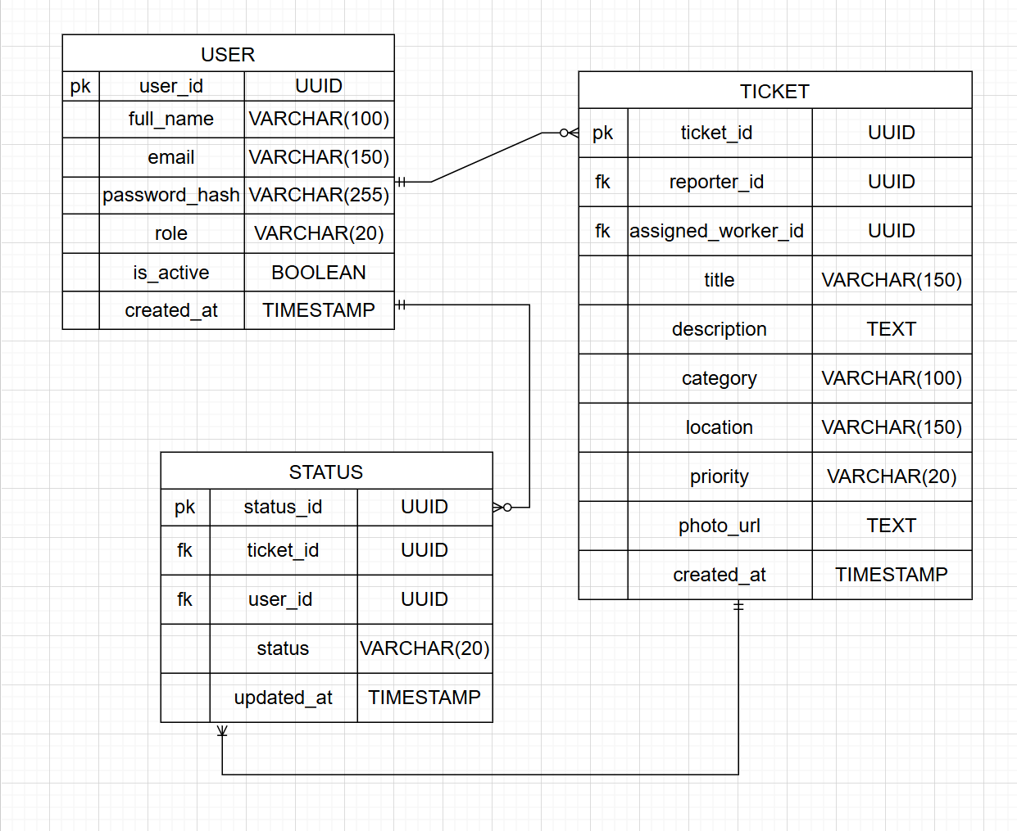

7. Technology Stack
• Mobile Framework: React Native (Expo) for cross-platform development on Android and iOS
• Backend Runtime: Node.js with Express.js for building RESTful APIs
• Database: PostgreSQL relational database management system
• Authentication & Authorization: JSON Web Tokens (JWT) with Role-Based Access Control (RBAC)
• Password Security: bcrypt hashing for secure password storage
• Image Storage: Cloud-based storage service (e.g., Cloudinary or Firebase Storage)
• API Communication: RESTful APIs over HTTPS
• Version Control: Git with GitHub repository hosting
• Development Tools: Visual Studio Code and Postman for API testing
• Deployment Environment: Cloud hosting platform (e.g., Render or Railway) for backend deployment

8. Future Scope of the Project
While the current system fulfils the core requirements for facility management at GIU, the following features are proposed for future development to enhance system efficiency and user engagement:
• 1. Integrated Communication Module (In-App Messaging): To improve coordination, a commenting system will be implemented within the ticket detail’s view. This will allow workers and managers to exchange technical notes or progress updates directly on a specific ticket, reducing the need for external communication tools.
• 2. Intelligent Duplicate Detection: To prevent the facility team from being overwhelmed by redundant reports, a "Nearby Issues" warning will be developed. When a user selects a location, the system will query existing active tickets for that area and alert the user if the issue has already been reported.
• 3. Management Analytics Dashboard: An administrative reporting tool will be added to provide high-level insights into campus health. This includes data visualizations for the "Average Time to Resolution" and "Top Maintenance Categories," helping the university allocate resources more effectively based on historical data.
• 4. Real-Time Emergency Notifications: Leveraging the Expo Push Notification service, the system will be enhanced to send instant high-priority alerts to workers. This ensures that "Urgent" or "Sustainability-related" issues—such as water leaks or fire hazards—are addressed with immediate priority.

